Image Analysis:

Why ?

Extracting built-up areas from optical satellite images is a crucial element in urban planning and land usage, but it is a complex task that continues to pose challenges. The intricate backgrounds in optical satellite images can pose challenges for effectively extracting built-up areas using existing methods.

What?

To overcome this challenge, the study proposes "The Optimum Index Factor (OIF)" as a statistical metric that can assist in identifying the ideal combination of three bands for a satellite image (Bhattacharjee Sukanta Mahavidyalaya and Debdip 2013).This enables accurate selection and extraction of built-up areas from the image.

Out of all the possible combinations of three bands, the optimal choice is the one that contains the most relevant "information" while minimizing the presence of redundant or "duplicated" data (Bhattacharjee Sukanta Mahavidyalaya and Debdip 2013).

How ?

The Landsat-8 Thematic Mapper (TM) has a 30-meter resolution, provides six different bands was taken as data set for initial chosen study area of Pune. This study aims to determine the optimal combination of three bands using Landsat TM satellite digital data for the years 2002 and 2022 to extract relevant information for Pune, Maharashtra, India. For this particular analysis, all six bands were utilized, resulting in 19 possible combinations of three bands, which were subsequently analyzed using the OIF metric. The band combination of 3-4-5 for the 2002 image achieved the highest OIF value of 0.104037641, earning it the top rank in the analysis. On the other hand, for the 2022 image, the band combination of 1-4-5 produced an OIF value of 0.084015, which was the highest among all analyzed combinations for that particular image.

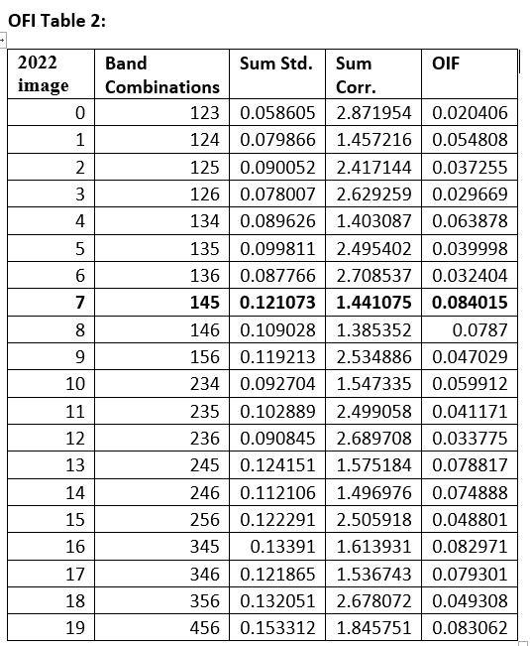 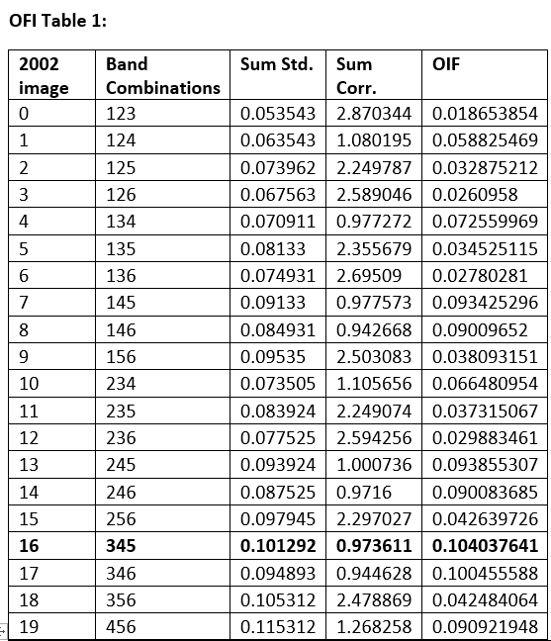

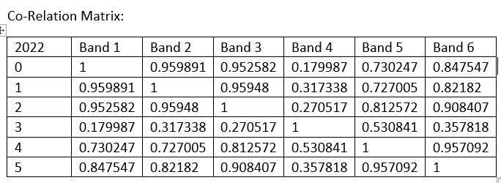

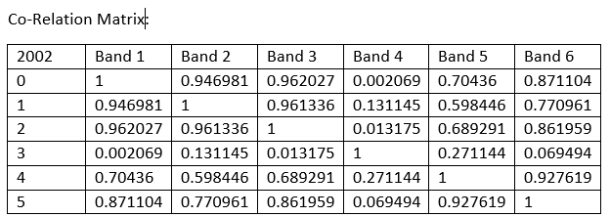

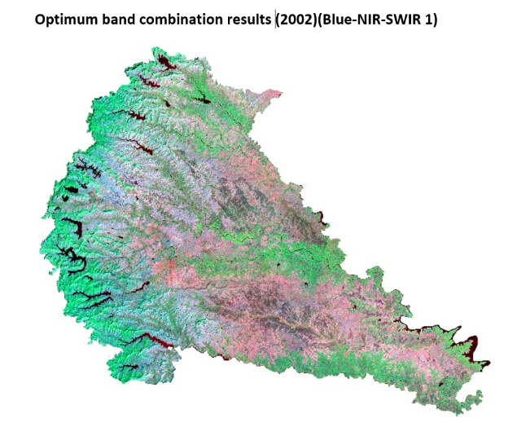

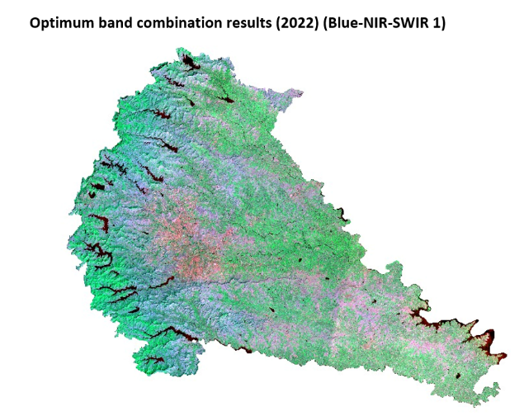

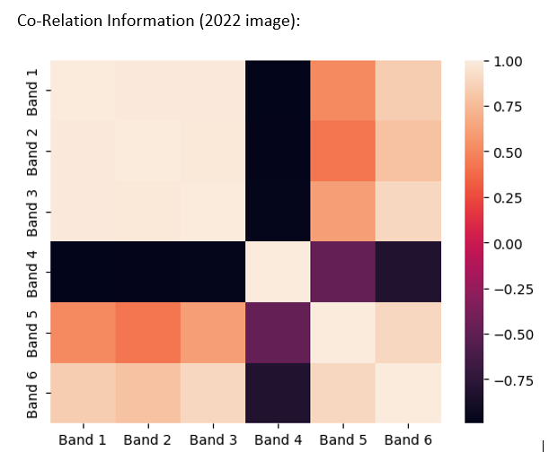

# References

Bhattacharjee Sukanta Mahavidyalaya, Debdip, and Bhattacharjee Debdip. 2013. “OPTIMUM INDEX FACTOR (OIF) FOR LANDSAT DATA: A CASE STUDY ON BARASAT TOWN, WEST BENGAL, INDIA PROSPECTS OF BRACKISH WATER FISHERIES IN TIDALLY ACTIVE INDIAN SUNDARBANS View Project OPTIMUM INDEX FACTOR (OIF) FOR LANDSAT DATA: A CASE STUDY ON BARASAT TOWN, WEST BENGAL, INDIA.” *International Journal of Remote Sensing & Geoscience (IJRSG)* 2(5). doi: 10.40707211.